the essential compenents of game design in 3d virtual worlds

A language learning perspective

Yu-Ju Lan
National Taiwan Normal University, yujulan@gmail.com

Abstract
Your abstract goes here - it should be between 150 and 250 words and different from the introductory text. You should save this template, and then create a new document using this file – rename it using the following document name: MRW-Section#-lastname-firstname-first-author-mm-dd-yy.

Key words
Three to six keywords or keyword phrases – avoid common words like ‘education’ or ‘research’ (keywords help with indexing)

Introduction – Heading 1 (bold, 14 pt. Cambria; 5 words or less)
Your chapter begins here . . . the normal text font used is Cambria 12 pt., fully justified with double spacing. The margins are one and a half inches top and bottom and left and right (all sides) on letter size (8.5 x 11 inch) paper. You may use the heading levels and styles in this document as a guide.
Use a hanging indent of 0.5 inches for each paragraph after the first paragraph (not indented) in each section. Each chapter in the MRW is intended to represent an in-depth study or synthesis of studies, an in-depth report of an innovative design, development, or practice, or an analysis of the results and/or implications of policy in a topical area pertinent to the section of the MRW in which the contribution will appear. Chapters should be between 7,000 and 17,000 words in length, not counting references and tables. An abstract (150-250 words) and 4 to 8 keywords/keyword phrases should be included. Follow APA 6 style guidelines for references and citations (see http://www.apastyle.org/ or http://owl.english.purdue.edu/owl/resource/560/01/) and use this template for your chapter.
Each chapter should be focused on an aspect of theory, research, design, development, technology integration, practice or policy relevant to the section in which it appears. A chapter should provide an in-depth discussion of the effort, and include a complete reference section, carefully following APA 6 guidelines. Each chapter should include a critical analysis, reflections on the effort, and implications for the future. Controversies, alternate points of view, and disagreements within the area should certainly be addressed. Authors will be expected to work in close collaboration with the editors and reviewers to ensure that the expectations of a contribution to the MRW are met. The section editor will have a decisive role in guiding revisions and determining acceptability for the MRW.

Heading level 2 (Initial caps, bold, Cambria 12 pt., no more than 5 words)
Your chapter continues here. Capitalize only the first word in your level 2 headings and any proper names.
Table 1. Notice that the table label is above the table and left justified with the table number italicized. Text in tables should be single spaced and 10 pt. Cambria.

Codes | Nodes Names | Explanations
Bathysphere | Hull | Submarine type things. Diameter = 7ft; Weight = 15 tons (dry weight, fully equipped, occupied); 7’ diameter and 15 tons weight

Use the following style for bullet and number lists, indented as shown.

- LISTbullet
- LISTbullet

- LISTnum
- LISTnum

Heading level 3 – italics, Cambria 12, first word and proper names capitalized (no more than 5 words)
Three heading levels should be sufficient for most well-structured chapters. You can include a fourth heading level which should have the heading word or words in bold followed by a period, followed by a space and then the beginning text for that section.
Use double quotation marks only for quoted items (followed by a page reference per APA 6). Use single quotation marks only when referring to a word or phrase itself (punctuation outside single quotes, inside double quotes). Use italics sparingly for emphasis. Use capitalization when referring to constructs.

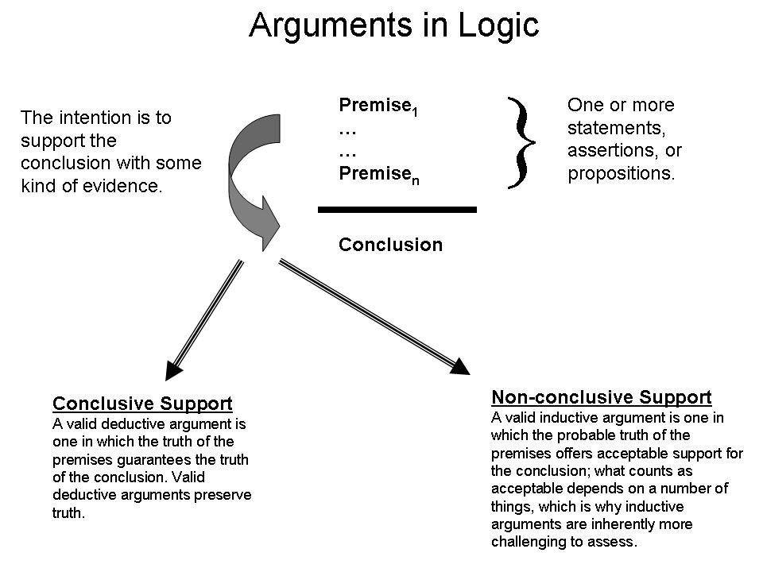
Figure 1. A figure label should be centered beneath the figure in Cambria 11 pt. font, short and descriptive – not a complete sentence, preferably to fit on one line.

Do not put explanatory information in the figure label; include very high resolution black and white, grayscale, or full-color images (JPG, TIFF, EPS) as well as links and other multimedia resources which can be shown in a standard browser (links cannot be browser specific and should not require special software to work unless there are directions for downloading and that software is freely available). Please also provide separate files for each figure in your chapter; named as follows: MRW-firstauthorlastname-figure-no.jpg, e.g., MRW-Spector-figure-1.jpg.

Heading level 1
Next section of your chapter begins here…

References
* Please follow APA 6 style very carefully for your references – see http://www.apastyle.org/ or http://owl.english.purdue.edu/owl/resource/560/01/, e.g.:

Eseryel, D., Ifenthaler, D., & Ge, X. (2011). Alternative assessment strategies for complex problem solving in game-based learning environments. In D. Ifenthaler, Kinshuk, P. Isaias, D. G. Sampson & J. M. Spector (Eds.), Multiple perspectives on problem solving and learning in the digital age (pp. 159-178). New York: Springer.
Ifenthaler, D., Kinshuk, Isaias, P., Sampson, D. G., & Spector, J. M. (Eds.). (2011). Multiple perspectives on problem solving and learning in the digital age. New York: Springer.
Ifenthaler, D., Masduki, I., & Seel, N. M. (2011). The mystery of cognitive structure and how we can detect it. Tracking the development of cognitive structures over time. Instructional Science, 39(1), 41-61. doi: 10.1007/s11251-009-9097-6

Acknowledgements
If you wish to acknowledge persons who contributed or sponsoring agencies, do so here in this optional section.

Author Information
Include the following information for each contributing author:

Complete name (last/family name, first/given name, and middle name or initial as appropriate and any desired suffix such as Junior, III, etc.):
Institutional affiliation:
Institutional address:
Complete mailing address:
Telephone number:
Fax number (optional):
Email address:
Website (optional):
Short biographical sketch (200 words maximum):

